Create file.

Garage system

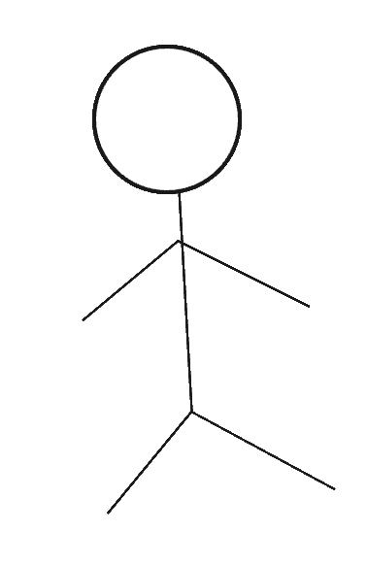
Check the vehicle.

Customer
Clerk
Mechanic
Create a receipt.

